|  |  |  |  |  |  |  |  |  |
| --- | --- | --- | --- | --- | --- | --- | --- | --- |
| |  | | --- | | [http://t0.gstatic.com/images?q=tbn:ANd9GcSzDerU_xWdrQe1Red2kCphQsb7QobgdzXxvcdkjizkR7eun79YaQ](http://www.google.com.au/url?sa=i&rct=j&q=refugees&source=images&cd=&cad=rja&docid=H3SwGuV7YQsqHM&tbnid=RTqkD8A4RXJlfM:&ved=0CAUQjRw&url=http://www.edmundrice.org.au/cbop/links-and-feeds/justice-advovacy-issues/154-refugees-and-asylum-seekers&ei=9mYIUtK1BIqKkwXL3YDIBA&psig=AFQjCNFgcT0mJe7WyD0L1YQSDjs6f2nvfA&ust=1376368685393006) | | Human Rights and Social justice Professional Development Booklet This purpose of this booklet is to provide pre-service teachers with essential strategies, activities, ideas and resources to use in the classroom to educate students about Human Rights.  The aim is to assist you in preparing lessons for students that cover a variety of text types and strategies to support planning and teaching of engaging lessons.  Human rights and social justice is such a large topic, and this informative PD will focus on the area of refugees for level six students. It encompasses texts that can be utilized from Foundation to year 10, including AUSVELS references to assist you.  All of the strategies, activities and ideas contained within this booklet can be adapted and altered to suit different year levels and can be used with numerous topics within the Human Rights area. | | We hope that this resource will be a valuable asset to all PST students who may be able to use this document in future planning.  Kim, Shannon and Michelle | |  | |  | | --- | | http://www.gooduniguide.com.au/var/thegooduniversitiesguide/storage/images/paid-profiles2/university-of-ballarat-tafe/3161-29-eng-AU/University-of-Ballarat-TAFE_large.gifEDBED3102Literacy Ed in the Global WorldProfessional Development PresentationWeek 5Tuesday 27th August 2013 | |  | | Kimberly Moore 30074561Michelle Thompson 30097437Shannon Baron30092723 | |

CONTENTS PAGE

Introduction Page 3

* The fundamentals of Human Rights Page 3
* The development of Human Rights Page 3
* Teaching Human Rights Page 3
* Human Rights Education Page 4
* Dealing with difficult issues Page 4

8 Reasons to teach about Human Rights Page 5

The Universal Declaration of Human Rights Page 6

Human Rights and Social Justice within AUSVELS F-10 Page 7

Key definitions Page 10

Strategies that can be used to teach about human rights Page 10

Using texts to teach human rights and social justice Page 16

Text resources for the classroom Page 18

Websites Page 21

Posters and iPAD Page 24

Scenarios Page 25

See Think Wonder worksheet Page 26

References Page 27

**Introduction**

**The Fundamentals of Human Rights**

‘***Human rights may be generally defined as those rights which are inherent in our nature and without which we cannot live as human beings. Human rights and fundamental freedoms allow us to develop fully and use our human qualities, our intelligence, our talents and our conscience and to satisfy our spiritual and other needs. They are based on humankind’s increasing demand for a life in which the inherent dignity and worth of each human being are accorded respect and protection. Their denial is not only an individual and personal tragedy but also creates conditions of social and political unrest, sowing the seeds of violence and conflict within and between societies and nations’***

**(United Nations, 2004, p. 5).**

**The Development of Human Rights**

The history of human rights has been shaped upon major world events with the struggle for dignity, freedom and inequality everywhere.The turmoil and atrocities of the Second World War and the growing struggle of nations for independence, prompted the countries of the world to create a forum to deal with some of the war’s consequences and, in particular, to prevent the recurrence of such appalling events. This forum was the United Nations. The United Nations (UN) was formed in 1945. It restored and reaffirmed the faith in human rights for all people and became the founding charter central. The United Nations adopted the ‘Universal Declaration of Human Rights’ on the 10th of December, 1948. This declaration was the first major achievement for the UN and continues to be a powerful document that exerts an enormous impact on people’s lives all over the world (United Nations, 2004).

The first achievement of significance for the newly formed United Nations was the Universal Declaration of Human Rights

(UDHR). This declaration was adopted by the United Nations General Assembly on the 10th of December 1948. This powerful document continues to have an enormous impact on people’s lives all over the world (United Nations, 2004).

For the first time in history, the declaration was considered to have universal value for human rights and fundamental

freedoms which were set forth in such detail (United Nations, 2004)

**Teaching Human Rights**

Teaching students about human rights involves developing their knowledge, skills and values of human rights. Teaching students in the classroom is not just about lessons, but lessons for life. It incorporates relevance to our daily life and experiences, empowering individuals to defend their own rights and the rights of others. This is an important investment for our future, which is aimed at creating a society where the human rights of every individual are valued and respected.

It is important for all students to explore and develop conclusions as they grow into young adults and onto adulthood. By giving young people an opportunity to express their feelings and what they think and feel, gives them the benefit to explore rights and issues and reflect on their own experiences, and experiences of other human beings.

Educators need to ensure that their teaching is not preaching. It needs to be taught in a way that respects all human rights in the classroom and the school community. The environment is also a great tool for students to learn about human rights as the behavior needs to be modeled by the teacher and school to help students understand and reflect. An example of this is the teacher speaking to his/her class, ‘Today we are going to learn about freedom of speech, shut up in the back row!’ This is not modeling behavior and is hypocritical to the topic. Students will learn more about the teacher exerting power than human rights. “Students spend a good deal of time studying teachers and can develop a good understanding of teachers’ beliefs, a teacher who behaves unjustly or abusively will have little positive effect” (United Nations, 2004, p.22). It is imperative for teachers to involve all facets of the school community, not only students, but school administrators and parents can be active as a school community. Human rights can therefore benefit all people within the community (United Nations, 2004).

**Human Rights Education**

It is a teacher’s role to “create opportunities for students to truly understand and accept social responsibilities” (United Nations, 2004, p.22). Therefore as teachers we must ensure that we educate students correctly on the basic human rights and assist them in gaining the knowledge to appropriately interact in the world around them.

What Human Rights Education includes:

1. The reinforcement of respect for human rights and fundamental freedoms
2. The growth of individual personalities and the sense of its dignity
3. The promotion of the importance of understanding, tolerance, gender equality and friendship among all individuals regardless of their racial, national, ethnic or religious groups
4. The ability to ensure that all individuals have the ability to participate in a free society
5. The development of activities that ensures the maintenance of peace occurs

(United Nations, 2004)

**Dealing with difficult issues**

Sometimes controversial and sensitive subjects come up when students begin to examine human rights. Teachers need to remain constantly alert to student discomfort and potential disagreement. Teachers should acknowledge that human rights necessarily involve conflicts of values and that students will benefit from understanding these conflicts and seeking to resolve them. Sometimes teachers meet resistance to human rights education on the ground that it imposes non-native principles that contradict and threaten local values and customs. Teachers concerned about resistance from administrators should meet with them in advance, share goals and plans for the class, and explain about the United Nations human rights framework and related educational initiatives (such as the United Nations Decade for Human Rights Education). Encourage other teachers, parents and school community members to visit your class – they may themselves benefit from human rights education! (United Nations, 2004).

## **8 reasons to teach children about Human Rights**

1.    **Develops intercultural understanding** – Global education provides an appreciation of Australia’s social, cultural, linguistic and religious diversity, and the ability to relate to and communicate across cultures. Teaching students about the world and other cultures increases social and cultural awareness, breaks down stereotypes, enables a broader view of the world and strengthens children’s identity. Global education prepares young people to understand and interact within a culturally diverse and globally interconnected world. (Robinson, 2013)

2.    **Builds social skills** – Education about social justice and human rights allows students to understand the importance of treating people equitably and the responsibilities we all have to protect the rights of others. Learning about child rights supports listening skills, respect, empathy and anti-bullying behaviours. (Robinson, 2013)

3.    **Develops ethical understanding** –Technologies bring local and distant communities into classrooms, exposing students to knowledge and global concerns as never before. Complex issues require responses that take account of ethical considerations such as human rights and responsibilities and global justice. Ethical understanding assists students to become confident and creative individuals and active and informed citizens. (Robinson, 2013)

4.    **Supports Australian Curriculum** – Global education on child rights aligns with Australian Curriculum learning areas of Humanities and Social Sciences, and Health, as well as general capabilities of personal and social capability, ethical understanding and intercultural understanding (Robinson, 2013). Education on child rights is also supported in The Australian National Curriculum Early Years Learning Framework, for educating children birth to five years, which highlights a critical principle of ‘Respect for Diversity’ (Australian Government Department of Education, Employment and Workplace Relations, 2013, np) with a main learning outcome as ‘Children are connected with and contribute to their world’ (Australian Government Department of Education, Employment and Workplace Relations, 2013, np).

5.    **Motivates student learning** – Connecting classroom knowledge with situations outside the classroom creates personal meaning and significance. Teaching child rights leads to lifelong learning which is significant to each child’s life, motivating deeper knowledge and understanding. (Robinson, 2013)

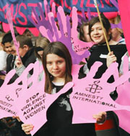6.    **Creates a safer school** – Teaching children about their rights can reduce exclusion and bullying, improve teacher-pupil relationships and make for more mature, responsible students. It positively affects the relationships, teaching approaches, attitudes and behaviour of everyone at your school. It provides children with the opportunity to model these rights and responsibilities within their peer groups and wider community, creating a rights-respecting ethos in your school. (Robinson, 2013)

7.    **Children realise their rights** – By recognising their own rights they become aware of how they should be treated by others and how to stand up for these rights. Children gain an appreciation of rights that are met and view their life from a global perspective. (Robinson, 2013)

8.    **Empowers students to become active citizens** – Teaching children about universality of children’s rights and the extent to which these are denied builds a generation that is socially responsible. Meeting all children’s rights in our lifetime is a real possibility. It is critical then to educate children as the future leaders of our society. Students learn to take responsibility for their actions, respect and value diversity and see themselves as global citizens who can contribute to a more peaceful, just and sustainable world. (Robinson, 2013)

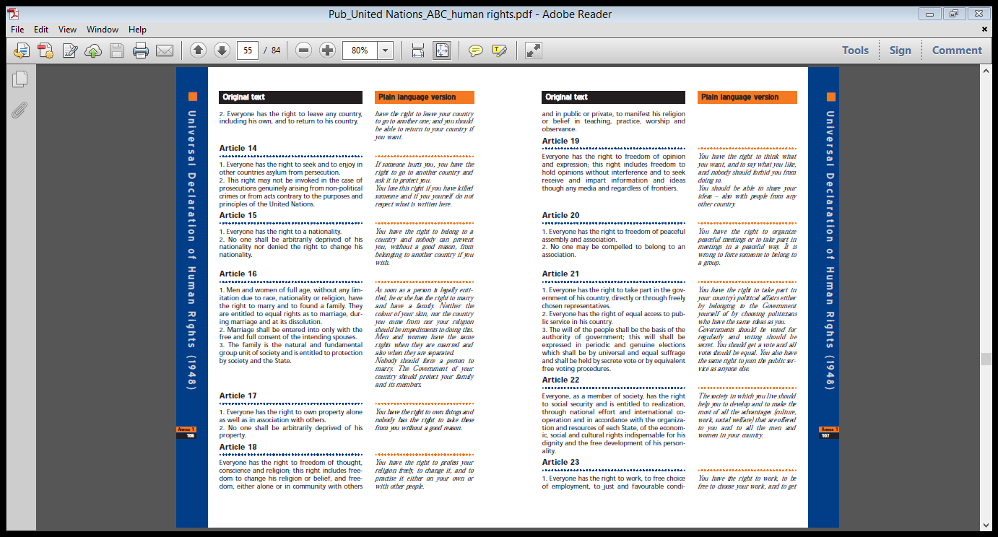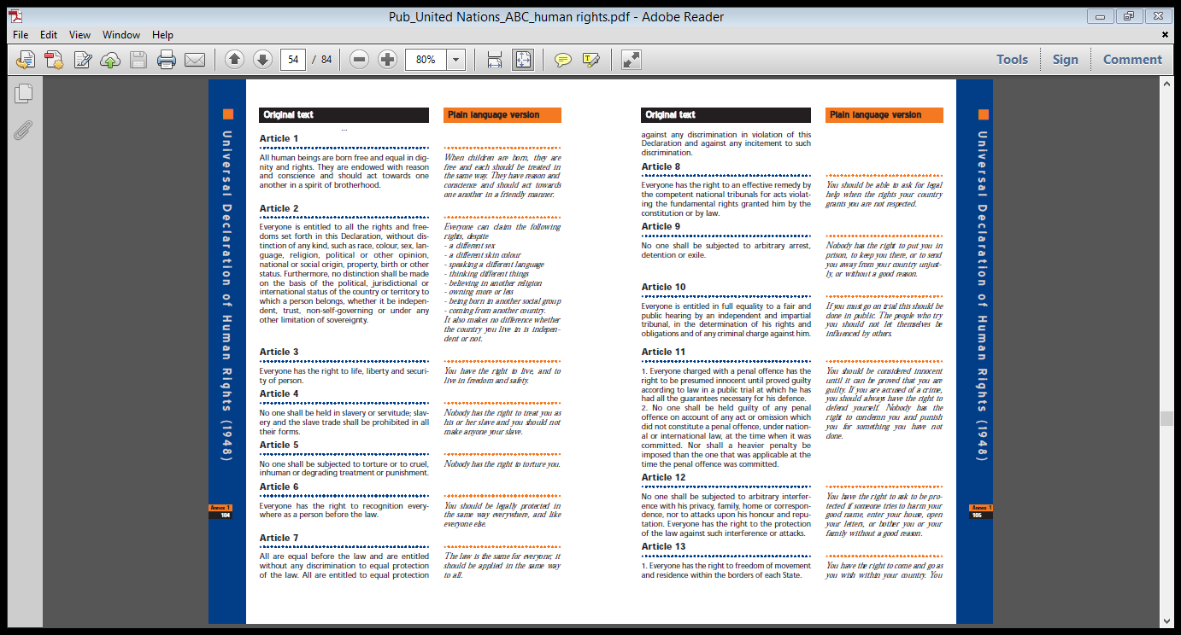The Universal Declaration of Human Rights (*In original and simple format)* (United Nations, 2004)



## **AusVELS P-10 that relate to the topic of Human Rights and Social Justice**

**Foundation:**

* “Understand that English is one of many languages spoken in Australia and that different languages may be spoken by family, classmates and community” (VCAA, 2013)
* “Recognise that texts are created by authors who tell stories and share experiences that may be similar or different to students’ own experiences” (VCAA, 2013)

**Level 1:**

* “Respond to texts drawn from a range of cultures and experiences” (VCAA, 2013)

**Level 2:**

* “Understand that spoken, visual and written forms of language are different modes of communication with different features and their use varies according to the audience, purpose, context and cultural background.” (VCAA, 2013)

**Level 3:**

* “Create imaginative texts based on characters, settings and events from students’ own and other cultures using visual features, for example perspective, distance and angle.” (VCAA, 2013)

**Level 4:**

* “Understand that social interactions influence the way people engage with ideas and respond to others for example when exploring and clarifying the ideas of others, summarising their own views and reporting them to a larger group.” (VCAA, 2013)

**Level 5:**

* “Recognise that ideas in literary texts can be conveyed from different viewpoints, which can lead to different kinds of interpretations and responses.” (Victorian Curriculum and Assessment Authority VCAA, 2013)
* “Identify aspects of literary texts that convey details or information about particular social, cultural and historical contexts.” (VCAA, 2013)
* “Understand that patterns of language interaction vary across social contexts and types of texts and that they help to signal social roles and relationships.” (VCAA, 2013)
* “Understand how to move beyond making bare assertions and take account of differing perspectives and points of view.” (VCAA, 2013)

**Level 6:**

* “Make connections between students’ own experiences and those of characters and events represented in texts drawn from different historical, social and cultural contexts.” (VCAA, 2013)

**Level 7:**

* “Identify and explore ideas and viewpoints about events, issues and characters represented in texts drawn from different historical, social and cultural contexts.” (VCAA, 2013)
* “Understand how accents, styles of speech and idioms express and create personal and social identities.” (VCAA, 2013)

**Level 8:**

* “Explore the ways that ideas and viewpoints in literary texts drawn from different historical, social and cultural contexts may reflect or challenge the values of individuals and groups.” (VCAA, 2013)
* “Understand and explain how combinations of words and images in texts are used to represent particular groups in society, and how texts position readers in relation to those groups.” (VCAA, 2013)
* “Explore the interconnectedness of Country and Place, People, Identity and Culture in texts including those by Aboriginal and Torres Strait Islander authors” (VCAA, 2013)
* “Recognise and explain differing viewpoints about the world, cultures, individual people and concerns represented in texts.” (VCAA, 2013)

**Level 9:**

* “Interpret and compare how representations of people and culture in literary texts are drawn from different historical, social and cultural contexts.” (VCAA, 2013)
* “Explore and reflect on personal understanding of the world and significant human experience gained from interpreting various representations of life matters in texts.” (VCAA, 2013)
* “Interpret, analyse and evaluate how different perspectives of issue, event, situation, individuals or groups are constructed to serve specific purposes in texts.” (VCAA, 2013)

**Level 10:**

* “Compare and evaluate a range of representations of individuals and groups in different historical, social and cultural contexts.” (VCAA, 2013)
* “Evaluate the social, moral and ethical positions represented in texts.” (VCAA, 2013)
* “Analyse and evaluate how people, cultures, places, events, objects and concepts are represented in texts, including media texts, through language, structural and/or visual choices.” (VCAA, 2013)
* “Identify and analyse implicit or explicit values, beliefs and assumptions in texts and how these are influenced by purposes and likely audiences.” (VCAA, 2013)
* “Understand how language use can have inclusive and exclusive social effects, and can empower or disempower people.” (VCAA, 2013)

## Why teach about Refugees?

There are increasing numbers of people who are not able to protect themselves from the troubles of their homelands. One in every one hundred people are forced to flee persecution and they require protection from the global community. Refugees are a painful, living reminder of the failure of societies to exist and live in peace. It is our human responsibility to help those people who are forced to flee their homes. This issue is linked to concepts such as justice, equality, tolerance, freedom, minority rights and the formation of community. There are many refugees in countries all over the world and issues about refugees and asylum seekers are constantly in the media. Many people in our country do not understand the reasons why refugees flee their homes, and this is not just our younger generation. Stereotypes are created, fueling myths and misunderstanding. Education is an important tool that must be used to combat the misunderstandings through the understanding of the issues affecting refugees (United Nations, 2004).

Students often struggle with the topic of refugees. They are unable to fully comprehend issues concerning refugees and it is important for teachers to ‘humanise’ the issue by bringing the issue ‘close to home’ by using specific examples and stories. Teachers can do this through a variety of teaching strategies and tools through reading, writing, visual tools such as DVD’s and personal testimonies. Activities need to provide students the ability to develop their knowledge of refugees through the encouragement of empathy and tolerance of others (United Nations, 2004).

*“Education is the most powerful weapon which you can use to change the world”*

*– Nelson Mandela*

**KEY DEFINITIONS**

**Refugee:** is a person who is outside their own country and is unable or unwilling to return due to a well-founded fear of being persecuted because of their race, religion, nationality, membership of a particular social group or political opinion (Australian Human Rights Commission, 2013).

**Asylum seekers:** are people who have fled their own country in fear of persecution and who have sought safety in another country (Queensland Museum, 2013).

**Internally displaced person: “**are people who have fled their homes in fear of persecution or conflict, or because of natural disasters, but are still within their own countries boundaries” (Queensland Museum, 2013, p. 6).

**Migrant:** “someone who has chosen to leave their own country and has been accepted by another country for settlement” (Queensland Museum, 2013, p.6).

## Activities to increase student’s knowledge about Refugees:

## *While these activities provided are used in context for students at AusVELS level 6 about refugees they can easily be modified and used for students at all AusVELS levels from Foundation-10 in regard to all topics relating to human rights and social justice.

|  |  |  |  |  |
| --- | --- | --- | --- | --- |
| **Activity** | **AusVELS standards addressed for level 6** | **Moderations to make this activity easier** | **Moderations to make this activity more difficult** | **Assessment** |
| **See, Think, Wonder**In this activity an image is presented to students. Students have to write down all that they see in the image, what they think is happening and what the positives and negatives of the picture are. For example in regards to a unit on Human Rights an image of some refugees could be shown. | “Use comprehension strategies to interpret and analyse information and ideas, comparing content from a variety of textual sources including media and digital texts.” (VCAA, 2013) | An image that did not have as much going on could be used. This way students would not have as much to comprehend.This activity could also be made easier by getting students to verbally complete each of the sections of the task rather than getting them to write it down. | A more controversial image could be used as this would give the student more to question.You could also get students to complete some kind of writing piece that was based around the image used in this activity. | Students ‘See Think Wonder’ worksheets collected by the teacher. |
| **What is a….?**In this activity students are asked to write down what they think the words ‘Asylum seeker’, ‘Refugee’, ‘Internally displaced person’ and ‘Migrant’ mean.Definitions are then provided to students of what each of these words actually mean. This is done using different cards, some cards have the words while others have the definitions written on them. | “Participate in and contribute to discussions, clarifying and interpreting ideas, developing and supporting arguments, sharing and evaluating information, experiences and opinions.” (VCAA, 2013)“Compare texts including media texts that represent ideas and events in different ways, explaining the effects of the different approaches” (VCAA, 2013) | To make this task easier students could complete it in groups. This would allow for students discuss the different words and share the knowledge that they have with each other.Completing the task of matching the cards with the definitions and words could be completed as a class with the teacher directing. | Students could be given the words and definitions on different cards their task would then be to match the correct definition with the correct word. | Student’s ability to match up the correct word with the correct definition used as a form of assessment. |
| **Research**Students are to conduct research into the topic of Refugees. This could be completed using the internet, books, news reports and newspapers. | “Select, navigate and read texts for a range of purposes, applying appropriate text processing strategies and interpreting structural features, for example table of contents, glossary, chapters, headings and subheadings” (VCAA, 2013)“Use comprehension strategies to interpret and analyse information and ideas, comparing content from a variety of textual sources including media and digital texts” (VCAA, 2013) | This task could be made easier by providing students with the websites, books, news reports and newspapers that they could access to find their information.Key terms and questions that students are to look for could also be provided. | This task could be made more difficult by not providing students with any resources of where they could conduct their research and getting them to conduct the research entirely by themselves.You could also get students to delve deeper into the research and find a greater level of information on the topic. | The amount of research that students complete is assessed through the teacher conducting interviews (Krause, Bochner, Duchesne & McMaugh, 2010) with each student. |
| **Pack a suitcase** Students are to imagine that they are leaving their home forever and have only a few minutes to pack a bag with some of their belongings. They must remember that they have to be able to carry their bag with them everywhere that they go and must decide which items they could not live without. | “Participate in and contribute to discussions, clarifying and interrogating ideas, developing and supporting arguments, sharing and evaluating information, experiences and opinions” (VCAA, 2013) | Students could be provided with a large image of a suitcase or bag and you could get them to draw what they would bring with them. | This could be completed in groups, making the task more difficult as each individual has different views on what items are important to them.You could give students a certain number, and this is the amount of items that they could take (the lower the number the harder the task would get). | The pack a suitcase worksheets collected after students complete the task |
| **Role play**Students are provided with a scenario about refugees that they must act out. Each student takes on a different role. Not only does this raise student’s awareness of refugees but it also enables them to relate to the experiences that they may be going through. | “Make connections between students’ own experiences and those of characters and events represented in texts drawn from different historical, social and cultural contexts” (VCAA, 2013) | Simpler scenarios could be provided to students of a lower level. | More controversial scenarios could be provided to students at a higher level. | These scenarios could be presented to the class or could be filmed and then viewed. |
| **Debate** The class is split up into two groups. One group is to debate why Asylum seekers should be let into Australia and the other is to debate why they should not be let into Australia | “Participate in and contribute to discussions, clarifying and interrogating ideas, developing and supporting arguments, sharing and evaluating information, experiences and opinions” (VCAA, 2013) | The teacher could provide some suggested arguments that students could use in their debate. | A more controversial issue could be used to be debated.A winning and losing team could be determined this would encourage students to be more competitive. | Anecdotal records (Krause, Bochner, Duchesne & McMaugh, 2010) could be taken on each students contribution to the debate |
| **Compare** Students are to read a case study of an individual who is a refugee. They are to compare and contrast the living conditions of individual from the case study to their own lives. Students then have to determine which of the basic human rights that the person from the case study does or does not have. | “Make connections between students’ own experiences and those of characters and events represented in texts drawn from different historical, social and cultural contexts” (VCAA, 2013) | Easier to read case studies could be provided to students of a lower level. | More difficult to read case studies could be provided to students who were at a higher level.Questions about the case study could be provided for students to answer. | The teacher could use questioning (Krause, Bochner, Duchesne & McMaugh, 2010) to determine what individuals had taken from reading the case studies |
| **Class discussions** Class discussions could be used to broaden student’s knowledge on the topic of refugees. It enables students to learn from different students points of view and encourages them to think of things that they otherwise may not have thought of. | “Participate in and contribute to discussions, clarifying and interrogating ideas, developing and supporting arguments, sharing and evaluating information, experiences and opinions.” (VCAA, 2013) | Simpler discussion topics could be used by students who were at a lower level. | More in depth discussion topics could be used by students of a higher level. | Student’s involvement and responses in the discussion could be used as a form of assessment. |
| **News report** Students are to create a mock news report on the issue of human rights. These can be either filmed or performed to the class. | “Plan, rehearse and deliver presentations, selecting and sequencing appropriate content and multimodal elements for defined audiences and purposes, making appropriate choices for modality and emphasis” (VCAA, 2013)“Use interaction skills, varying conventions of spoken interactions such as voice volume, tone, pitch and pace, according to group size, formality of interaction and needs and expertise of the audience” (VCAA, 2013) | Students could just present the basic facts about refugees in their news report. | Students could present a more detailed news report about refugees that includes facts and figures and coverage of an actual story that involves refugees. | Peer assessment (Krause, Bochner, Duchesne & McMaugh, 2010) could take place where students assess each other’s news reports |
| **Effects**In groups students are to create four different semantic webs (Hancock & Leaver, 2006) on how being forced to leave homes in a hurry would affect individuals:1. Health2. Safety3. Family4. Future | “Participate in and contribute to discussions, clarifying and interrogating ideas, developing and supporting arguments, sharing and evaluating information, experiences and opinions” (VCAA, 2013) | Students of lower levels could be placed with students from higher levels. This would provide students of lower levels to have some assistance. | Students of the higher level would be expected to provide more information on their semantic webs (Hancock & Leaver, 2006) with a greater level of detail. | The ideas written on the semantic webs (Hancock & Leaver, 2006) would provide the teacher with an indication of the students level of understanding |
| **What would it be like?**Students are to create a diary about what it would be like to be a refugee. They must outline some of the experiences that a refugee may have and include some of the emotions that they might experience. | “Investigate how vocabulary choices, including evaluative language can express shades of meaning, feeling and opinion” (VCAA, 2013)“Experiment with text structures and language features and their effects in creating literary texts, for example, using imagery, sentence variation, metaphor and word choice” (VCAA, 2013)“Plan, draft and publish imaginative, informative and persuasive texts, choosing and experimenting with text structures, language features, images and digital resources appropriate to purpose and audience” (VCAA, 2013) | Students of a lower level would not be expected to write as much as those at a higher level.This task could also be made easier by getting students to have an illustrated diary with just a few sentences to go with each image. | Students could use more descriptive language to ensure that the reader really gets a feel to what this individuals experience would be like. | The teacher could collect up the students diary entries and keep these in student portfolios (Winch, Johnston, March, Ljungdahl & Holliday, 2010) |
| **Refugee Wall**Have a wall somewhere in your classroom where you can hang newspaper articles/ anything in the media about refugees. This can be referred to by students. | “Use comprehension strategies to interpret and analyse information and ideas, comparing content from a variety of textual sources including media and digital texts” (VCAA, 2013)“Compare texts including media texts that represent ideas and events in different ways, explaining the effects of the different approaches” (VCAA, 2013) | This could be used regardless of what level the students were. | This could be used regardless of what level the students were. | N/A |
| **Create a refugee camp**In groups students are to imagine that they are in charge of creating a refugee camp with about 1,000 people. They must create their camp so it takes into account the basic human rights of the people living there. They must use the following minimum requirements:15 L of water (per person per day)2,100 calories of food (per person per day)1 toilet for 20 peopleA maximum walking distance of 50 minutes from shelter1 tent or plastic sheeting for a family of 5Immunisation against measlesEducation | “Participate in and contribute to discussions, clarifying and interrogating ideas, developing and supporting arguments, sharing and evaluating information, experiences and opinions” (VCAA, 2013) | The expectations of the refugee camp would not be as high for students of a lower level. For an example they may just have to roughly design and write about what their camp would include. | Students of the higher level would be expected to take into account the calculations of each individual’s needs, where the camp would be located, the costs of the camp, the positives and negatives of the camp and how they would deal with things such as educating individuals to live independently in a new country. | This task could be assessed through the means of a rubric that had criteria that students had to meet |
| **Persuasive piece** Students are to write a persuasive piece to why or why not refugees should be allowed in Australia. | “Plan, draft and publish imaginative, informative and persuasive texts, choosing and experimenting with text structures, language features, images and digital resources appropriate to purpose and audience” (VCAA, 2013) | Only one or two persuasive points could be addressed in their piece of writing. | Five or six persuasive points could be addressed in their piece of writing. | Drafts of the persuasive pieces could be viewed by the teacher at various stages and the final piece could be collected up at the end |
| **Move** Students are to put together a list of why people would move voluntarily and why some would move against their will. | “Participate in and contribute to discussions, clarifying and interrogating ideas, developing and supporting arguments, sharing and evaluating information, experiences and opinions” (VCAA, 2013) | This could be completed as a class to make this task easier. | The task could be completed individually to make this task a bit more difficult. | A whole class discussion could take place after this activity so that the diverse ideas that students could be made known to all. |
| 1. **Digital story**   Students are to create a digital story using ICT. This story must be about refugee migration and about the journey that individuals undertook. They must research the content behind their story and plan and draft it. They can use programs such as Windows Movie Maker, IMovie, PowerPoint or photo story. | “Plan, draft and publish imaginative, informative and persuasive texts, choosing and experimenting with text structures, language features, images and digital resources appropriate to purpose and audience” (VCAA, 2013) |  |  | These digital stories could be presented to the class. |

## Using texts to teach Human Rights and Social Justice

*[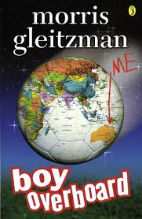](http://www.google.com.au/url?sa=i&rct=j&q=&esrc=s&frm=1&source=images&cd=&cad=rja&docid=wuFQP8RUyM6fRM&tbnid=N6JvH9JWTQLG6M:&ved=0CAUQjRw&url=http://www.penguin.com.au/products/9780141308388/boy-overboard&ei=ma4RUvHWJ8nUkwWnwoDoAQ&psig=AFQjCNEtp8P9PRHdhFAiwSl_ZeLiXaJoEA&ust=1376976915739074)*While a range of texts can be used to teach human rights and social justice to students of all levels from foundation-10. In this booklet we will focus on teaching the topic of refugees to level six students and therefore will use the text* ***‘Boy Overboard’*** *by Morris Gleitzman.*

**Basic Overview:** Boy Over board is about an Afghanistan boy named Jamal who embarks on a journey to Australia. After his Mother’s underground school for girls is discovered, Jamal and his family must flee the country but they get separated along the way. He travels with his sister, Bibi, as well as two other Afghanistan children that they meet. Together these children escape the hardship of their home country and face the unknown in the hopes of a better life. Jamal and his sister have a passion for soccer which keeps their spirits alive. They have no idea what’s at the end of the tunnel but their optimism, perseverance and courage leads them to truly believe that Australia will be their safe haven.

**Suited year levels:** This text deals with serious and confronting issues such as refugees and migration. Therefore, in a primary school setting would be most suitable for students in year 5 and 6.

**Strategies that can be used alongside this book to teach human rights:**

|  |  |  |
| --- | --- | --- |
| **Strategy** | **AusVELS link/s** | **Assessment** |
| **Predicting the story**  Students will predict what the story is about using the following words: Water, Sea, Taxi, Bomb, Refugee, Execution, Illegal, Boat, School, Soccer and Yusuf. | “Participate in and contribute to discussions, clarifying and interrogating ideas, developing and supporting arguments, sharing and evaluating information, experiences and opinions” (VCAA, 2013) | Anecdotal notes taken from students responses. |
| **What is this?**  By looking at the front cover of the text students are to record their thoughts in a brainstorm about what they think the text will be about. They are then to read the first chapter and complete a ‘Think Pair Share’ (Hancock & Leaver, 2006) with a partner. Students are then to add what they had learnt from the chapter reading and ‘Think Pair Share’ to their brainstorm. | “Use comprehension strategies to interpret and analyse information and ideas, comparing content from a variety of textual sources including media and digital texts” (VCAA, 2013) | Students responses to the ‘Think Pair Share’ (Hancock & Leaver, 2006) could be used to inform the teacher of students thought processes while completing this task. |
| **Plus, Minus and Interesting Chart** Students will each complete a Plus, Minus and Interesting Chart in their writing books for each of the following statements that are linked to these words.  **Refugees:** You have no choice but to leave your country.  **War:** Your country at war.  **Siblings:** Siblings should always be there for you.  **Home:** There’s no place like home**.** | “Investigate how complex sentences can be used in a variety of ways to elaborate, extend and explain ideas” (VCAA, 2013) | Writing books will be handed up to the teacher for assessment. Students will be marked on how the response to each statement and if they responded to all statements. |
| **Diary Entry**  Students are to pretend that they are a character from the text create a diary entry. Their diary entry must reflect their chosen character. | “Experiment with text structures and language features and their effects in creating literary texts, for example, using imagery, sentence variation, metaphor and word choice” (VCAA, 2013) | Diary entries could be collected up by the teacher and be used for assessment of the students writing. |
| **Character webs**  List the characters introduced in the novel and draw a character web including all the main characters and their relationships to one another. | “Make connections between students’ own experiences and those of characters and events represented in texts drawn from different historical, social and cultural contexts” (VCAA, 2013) | Students will share their responses to the class as a whole to show understanding. |
| **Where in the world**  Students are to research the country where the text was set. They must include basic information about the country such as its name, flag, location, longitude and latitude, the spoken language, most common religion and the currency. They may also include any other facts about the country that they find interesting. | “Make connections between students’ own experiences and those of characters and events represented in texts drawn from different historical, social and cultural contexts” (VCAA, 2013) | Students could complete an oral presentation (Hancock & Leaver, 2006) on the country that they chose to research. This would help them to demonstrate to their teacher and peers the knowledge that they have gained from the task. |
| **How does it end**  After reading the text students are to write what they think will happen next. They need to take into account the language, style, characters and context that the text was written in. (Swan, 2009) | “Create literary texts that adapt or combine aspects of texts students have experienced in innovative ways” (VCAA, 2013) | Students could get their peers to read over their piece of writing. Students could then provide each other with constructive feedback. |
| **Character Interviews**  Some students act as characters while other students act as the interviewee. The interviewee comes up with/asks questions to the character about things about them that the book did not portray. While the individual acting the character writes/ answers likely responses to the interviewees questions. | “Use interaction skills, varying conventions of spoken interactions such as voice volume, tone, pitch and pace, according to group size, formality of interaction and needs and expertise of the audience” (VCAA, 2013) | These interviews could be filmed and then reviewed again at a later date. |
| **What if….?**  After reading a chapter students are to consider alternatives outcomes to what the chapter outlines. What could have happened differently? What would have that meant? Would that have changed the outcome of the entire text? | “Select, navigate and read texts for a range of purposes, applying appropriate text processing strategies and interpreting structural features, for example table of contents, glossary, chapters, headings and subheadings” (VCAA, 2013) | Students could complete this on some form of graphic organiser. By viewing the graphic organiser the teacher would be able to recognise a student’s understanding of the text. |
| **Own migration history**  This will be a homework activity where students survey their family migration history and results will be collated as a class, mapping countries of origin.  Students can discuss questions such as “are we all migrants?”  (Global words survey work sheet available from website) | “Make connections between students’ own experiences and those of characters and events represented in texts drawn from different historical, social and cultural contexts” (VCAA, 2013) | Anecdotal notes will be taken on students ability to complete homework on time and response to the question “are we all migrants?” |

## Text teaching resources related to human rights and social justice

*\*Each of the above strategies could be used for all year levels with any of the following books*

**Books suited for younger primary students:**

[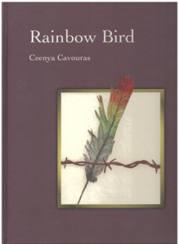](http://littleswagofbooks.files.wordpress.com/2013/04/rainbowbird.jpg)**Rainbow Bird written by Czenya Cavouras (Foundation)**

This is a very moving book written by a 14 year old. It tells the story of the journey from a destroyed country to refugee camps and eventually to having a future that has hope in it.

**The Colour of Home written by Mary Hoffman (Age 4+)**

This book deals with the difficulties that individuals face when moving to a new home. This is a story about a boy who is adjusting to this move that he just experienced and how at first he feels out of place in this new environment but that eventually he gets used to it.

[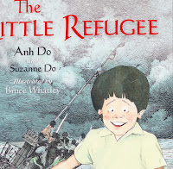](http://3.bp.blogspot.com/-JkGR7P32YzI/T93FDoR510I/AAAAAAAAAC0/zHjNA7jN2s0/s1600/IMG.jpg)**The Little Refugee written by Anh Do with Suzanne Do (4-8 years)**

Comedian Anh Do recounts his journey from war-tor Vietnam in an over-crowded boat and the challenges that they faced to get to Australia. He also speaks of the difficulties that they faced once they were in Australia.

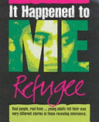**Refugee: It happened to me written by Angela Neustatter and Helen Elliot (4-8 years)**

This book has interviews with six young individuals who are either refugees or asylum seekers. These interviews inform the reader of the practical and emotional consequences that these individuals have experienced.

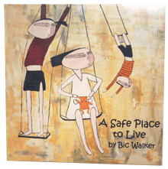**A Safe Place to Live written by Bic Walker (5+ years)**

This is a true story about a young girl’s journey as a refugee to Australia. She comes across pirates and is rescued by an oil tanker, before she has to wait in a refugee camp until she is sponsored to come to Australia.

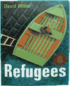

**Refugees written by David Miller (5-8 years)**

In this book two ducks become refugees when their swamp is drained. This is a great book to use for younger children as it introduces the topic of human rights without going into the great detail or depth of what can actually happen.



**W is for World: A Round the World ABC written by Kathryn Cave (5-9 years)**

This book informs individuals about the basic human rights and looks into the daily lives of children and adults around the world.

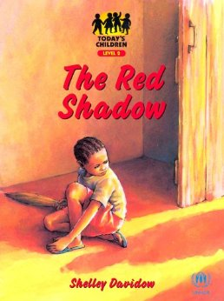

**The Red Shadow written by Shelley Davidow (5-9 years)**

This is a story about a refugee called Miri who returns home to her village after the war finishes. It deals with issues such as the rebuilding of her village and the reunification with her family.

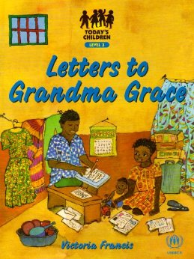**Letters to Grandma Grace written by Victoria Francis (5-9)**

This is a story that is told through letters from African children to their Grandma. It is a story about an African refugee family’s experiences, the hardships they face and how they become accustomed to their new home.

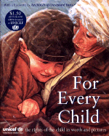

**For Every Child written by Caroline Castle (6-10 years)**

This is picture book which outlines the 15 most important rights of the child

[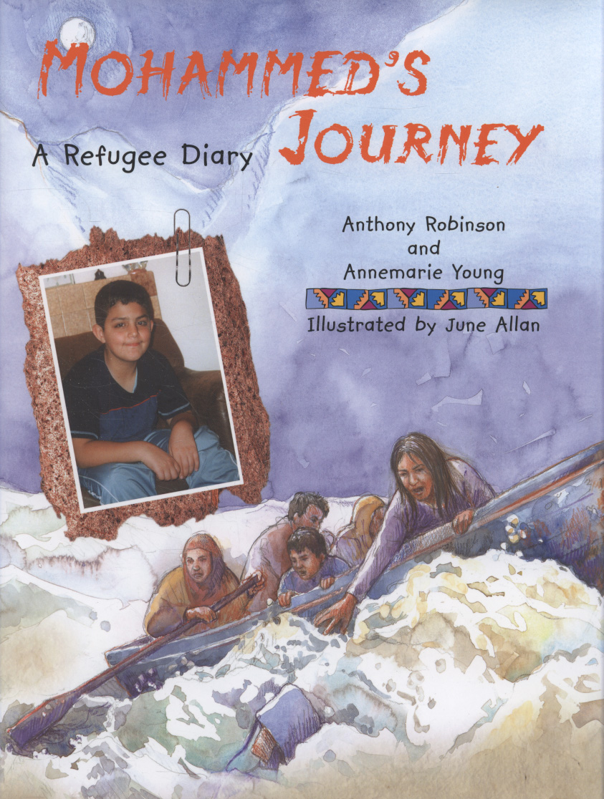](http://www.google.com.au/url?sa=i&rct=j&q=&esrc=s&frm=1&source=images&cd=&cad=rja&docid=mYMpeBRWth0TsM&tbnid=d_m9W6uYqpvKoM:&ved=0CAUQjRw&url=http://norlink.norfolk.gov.uk/02_Catalogue/02_005_TitleInformation.aspx?rcn=1845076532&&ei=HrIVUq67JorgkAXqlIDYAw&psig=AFQjCNE9WfzKfgny8P9ywHPtabIFiUOK7A&ust=1377239961043599)**Mohammed’s Journey written Anthony (7+ years)**

This is a true stroy about an Iraqi-Kurdish refugee boy and his journey from Iraq to England. The story explains the different steps of his journey and all of his different encounters.

*\*There are other texts similar to this such as Gervelie's Journey written by Anthony Robinson which is also a true story*

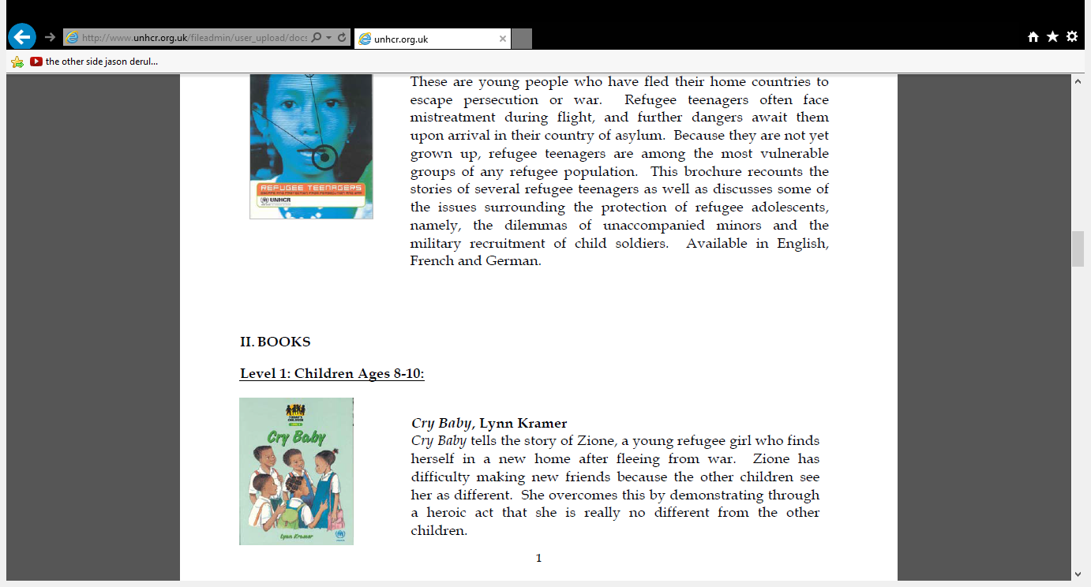

**Cry Baby written by Lynn Kramer (8-10 years)**

This is a story about a refugee girl who finds it difficult to make friends in her new home as she is different from the other children.

**Books suited for upper primary students:**

[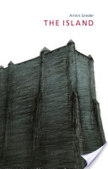](http://books.google.com.au/books?id=oEkZGp4V6ocC&printsec=frontcover&source=gbs_ge_summary_r&cad=0)**The Island written by Armin Greder (8-11 years)**

This books uses a metaphor to describe the way that fear can create artificial barriers between people in order to protect themselves. It suggests reason to why refugee camps exist throughout the world.

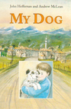

**My Dog written by John Heffernan (8-12 years)**

This book is about the ethnic cleansing of Yugoslavia seen through the eyes of a young boy. I would be a good book to use for an introduction on human rights and suffering.

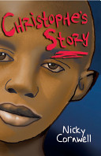

**Christophe’s Story written by Nicki Cornwell (8-11 years)**

This is a story about an 8 year old boy from Rwanda’s journey with his family to safety in England. It is a great boy that raises awareness about the experiences that some individuals go through.

[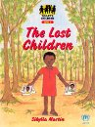](http://www.abebooks.com/servlet/BookDetailsPL?bi=2685217719&searchurl=an=sibylla+martin&amp;bsi=0&amp;ds=30)

**The Lost Children written by Sibylla Martin (10-12 years)**

This is a story about a girl named Ibuka and her brother and how they become separated from their family when fleeing their home, and end up at a centre for lost children.

[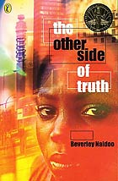](http://www.google.com.au/url?sa=i&rct=j&q=&esrc=s&frm=1&source=images&cd=&cad=rja&docid=BRGqmriFyvTc-M&tbnid=Gr76dR_rZSSbBM:&ved=0CAUQjRw&url=http://en.wikipedia.org/wiki/The_Other_Side_of_Truth&ei=UxoXUuW6DMLClAXxv4HYBg&psig=AFQjCNHxdcbMhFbisx4Coxonu9j4rB008Q&ust=1377332161322933)**The Other Side of Truth written by Beverley Naidoo (10-12 years)**

This book deals with different themes relating to human rights such as injustice, the freedom of speech, bullying and the strength of the family. The novel is set during 1995 in the aftermath of Ken Saro-Wiwa's

execution in Nigeria

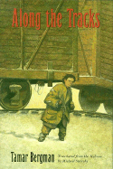**Along the tracks written by Tamar Bergman (11-14 years)**

This story tells the adventures of a young Jewish boy who is driven from his home by the

German invasion. He is separated from his family and experiences many hardships before he can enjoy a normal life again.

[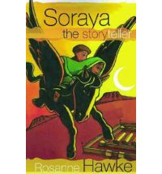](http://www.google.com.au/url?sa=i&rct=j&q=&esrc=s&frm=1&source=images&cd=&cad=rja&docid=E_FQECCtCEVqCM&tbnid=SQDzYEE-lTNvbM:&ved=0CAUQjRw&url=http://www.bookdepository.co.uk/Soraya-Storyteller-Rosanne-Hawke/9780734407092&ei=2OcWUtH6A8bQkgXN7oDgBg&psig=AFQjCNEEABDEo0qSOzkNvpuYLT5CQCtuAQ&ust=1377319236195410)

**Soraya the Storyteller written by Rosanne Hawke (10-12 years)**

This is a story about an 11 year old Afghanistan girl who is an asylum seeker. It explores how she adapts to life in Australia and is haunted by her father’s absence and the fear that she will have to return to Afghanistan.

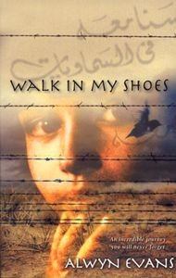**Walk in My Shoes written by Alwyn Evans (12+ years)**

This is about a refugee from Afghanistan who struggles to build a life for herself and her family in Australia.

**Books suited for upper secondary students:**

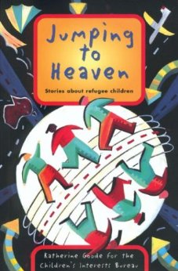

**Jumping to Heaven written by Katherine Goode (13+ years)**

This is a collection of short stories put together from interviews with refugee children from Bosnia, Cambodia, El Salvador, Herzegovina, Iraq, Sudan, and Vietnam who have come to Australia to escape persecution. It is a great book that helps to provide an insight into the lives of refugees.

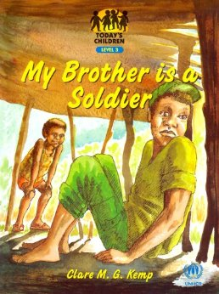

**My Brother is a Soldier written by Clare M. G. Kemp (13-14 years)**

This is about a child soldier in Africa and the problems he faces when he returns to his village and ties to live a normal life.

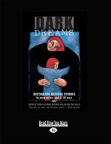**Dark Dreams: Australian Refugee Stories by young written by Sonja Dechian, Heather Millar and Eva Sallis (15+)**

These are some stories written by young writers aged between 11-20 years, that open individual’s eyes to what actually happens in the world around them. It helps students to recognise that unbearable events happen and that some of these are not too far away.

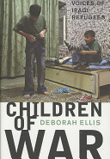**Children of war: Iraqi refugees speak written by Deborah Ellis (14-16 years)**

Debra Ellis interviewed more than 20 Iraqi children in order to get their experiences. This book tells the stories of these children and even includes little comments from the children themselves. It outlines the consequences of war and how these children were effected so greatly by something that they played no

part in.

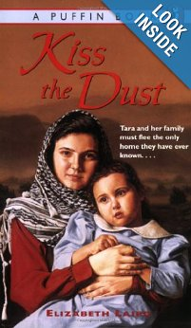

**Kiss the Dust written by Elizabeth Laird (12-17 years)**

This is about an Iraqi girl and her family and how they are forced to flee Iraq because her father is involved in the Kurdish resistance movement.

## Website resources related to human rights and social justice

## **Amnesty International Australia**

## <http://action.amnesty.org.au/hre/comments/refugees_rights_classroom_resources/>

## Great deal of information in refugees, asylum seekers and human rights. Contains lesson ideas relating to border security, fleeing from persecution to freedon using methods and strategies such as role play, games and group work.

## **Asylum Seekers Resource Centre**

## <http://www.asrc.org.au/>

## Contains a section on facts and myth busters.

## **The Australian Human Rights Commission**

## <http://www.humanrights.gov.au/education/topics/topic_race.html> Range of educational resources on all areas of human rights. Includes student activity sheers which can be downloaded from the website. ‘Face the Facts’ education resource which contains accurate and easy to understand information about migrants, refugees and asylum seekers.

**BBC News**

<http://news.bbc.co.uk/hi/english/static/in_depth/world/2001/road_to_refuge/default.stm>

Has a variety of resources on Refugee stories and photos. It has first-person testimonies and in-depth interviews to trace the journey from home into exile. It asks why refugees are still fleeing, where they go, and examines how we treat them.

**Behind the News:** Refugee videos

* ***Refugee Kids***<http://www.abc.net.au/btn/story/s3230871.htm>  
  A program helping a group of African refugee boys adjust in Australia.
* ***New Migrants***  
  <http://www.abc.net.au/btn/story/s3343578.htm>  
  A family of refugees talk about their arrival in Australia for the first time.
* ***Asylum Seekers***<http://www.abc.net.au/btn/story/s2881114.htm>  
  Explain who asylum seekers are, why they are trying to come to Australia and how the changes might affect them.  
  ***Detention Centers***  
  <http://www.abc.net.au/btn/story/s3044730.htm>  
  What a detention centre is.  
  ***Asylum Seekers***<http://www.abc.net.au/btn/story/s2551598.htm>  
  who are asylum seekers and why do people argue about them so much?

**CBC News**

<http://www.cbc.ca/news/background/refugeecamp/>

This website will students can use to discover exactly what a refugee camp is like.

**Coalition for Asylum Seekers, Refugees and Detainees (CARAD)**

<http://www.carad.org.au/>

CARAD are an active campaigner for change in the refugee determination conditions and process. They have become the agency of last resort for community based asylum seekers, a respected voice for refugee rights and advocacy and a source to educate students about the background of refugees.

**Centre for Multicultural Youth (CMY)**

<http://www.cmy.net.au/Publications>

Provides information sheets on issues affecting young people from migrant and refugee backgrounds. The sheets include a brief guide to meaningful consultation with young people from refugee and migrant backgrounds.

CMY also provides toolkits and information sheets that highlight good practice principles in building relationships with newly-arrived and refugee communities, as well as strategies to support engagement through sports and

recreation. These strategies could be used to help conduct community events for Refugee Week.

**Doctors without Borders (also known as Médecins Sans Frontières)**

http://www.doctorswithoutborders.org/events/refugeecamp/resources/

List of lesson plans including topics such as migration, being forced to leave, the differences between ‘shelters’ and

‘established homes’, food rations and malnutrition, water as a basic need and the need to raise awareness for refugees: The building awareness lesson could lead nicely into encouraging students to plan an event for

Refugee Week.

**Global Education** offers some excellent ideas for teaching activities for grades ranging from upper

primary to upper secondary. Topics include defining refugees, experiencing flight, life in a refugee camp, using statistics and more, with case studies from Sudan, Sri Lanka and the Thai-Burma border. Suggested activities include group discussion, research tasks, reports and debates topics.

**Global Words**

<http://www.globalwords.edu.au/>

The twelve units of work that for have been produced by World Vision Australia and the Primary English Teaching Association Australia (PETAA) to integrate the teaching and learning of English and global citizenship education. It has three sections which are junior primary, upper primary and junior secondary and each has a detailed unit on Refugees and Migration

**Oxfam**

<http://www.oxfam.org.uk/education/resources/category.htm?41>

Great lesson ideas and resources on the conflict in Darfur, war in Iraq and peace and conflict around the world in general. For example, the Darfur resources gives a teachers’ and students’ guide to the conflict (including testimonies from children living in refugee camps in Darfur) and aims to make a complex topic comprehensible to students aged 13 and over. Sections include a history of the conflict, stories from young people living in the camps about their daily lives, the fears they face, and their hopes for the future, information about Oxfam’s work in Darfur; and ideas for actions students might take about the issues.

**PEN**

http://www.pen.org.au

The Australian body that consists of 3 centres (Sydney, Melbourne and Adelaide) and is joined with International PEN which in total has 145 centres worldwide. Its purpose is to campaign on behalf of writers who have been silenced by persecution or imprisonment, and promoting the written word in all its forms.

**“Racism. No Way”**

<http://www.racismnoway.com.au/classroom/lesson_ideas/index_bytheme.html>

Anti-racism lessons and resources for Australian schools, has an incredible range of lesson plans and student worksheets ready for download. Lesson topics include racism, prejudice, cultural diversity, identity, language,

migration and refugees. The site also looks at dispelling some myths related to boat people, migrants and refugees.

**Refugee Camp in the Heart of the City**

http://www.doctorswithoutborders.org/events/refugeecamp/guide/

This virtual website that could be shown to student which gives them an insight to how the basic needs of people are not being met in such camps all over the world.

**Refugee Council of Australia (RCOA)**

http://www.refugeecouncil.org.au/

This site offers facts, statistics and useful information about refugees that could be used in range of literacy activities.

**The Refugee Claimants Support** **Centre**

<http://www.refugees.org.au/index.php/resources/for-schools>

Lesson plans for middle-school classes, as well as a range of supporting resources available for download.

## **Rethink Refugees**

## [www.rethinkrefugees.com.au](http://www.rethinkrefugees.com.au)

## This website contains personal stories of refugees who have sought asylum or were resettled in Australia. Includes other information about refugees.

**United Nations High Commissioner for Refugees (UNHCR)**

<http://www.unhcr.org.uk/resources/educational-resources.html>

Teacher’s guides and lesson plans, videos, booklets andposters.

**UN Works**

<http://www.un.org/works/goingon/refugees/lessonplan_refugees.html>

Lesson plans that includes a variety of activities and discussion questions for teachers to utilise. The activities aim to broaden students’ understanding of refugees and the problems that they face, while encouraging students to develop empathy for their plight.

**Sanctuary Australia Foundation**

<http://www.sanctuaryaustraliafoundation.org.au>

This website has some great case studies that students can use to gain an insight into the lives of refugees. It also has some documentaries that students can watch that gives them a visual representation.

## Posters for the classroom

## The 2012 Refugee Week poster (below) is available

from RCOA offices and pick-up points across the

country. Visit www.refugeeweek.org.au for details or

email [vols@refugeecouncil.org.au](mailto:vols@refugeecouncil.org.au).

UNHCR’s “Lego” Posters (below) are a great resource

to use when thinking about how to challenge some of

the negative stereotypes towards refugees. See below

for an example. To view all the posters go to

[www.unhcr.org.au/pdfs/140603LegoA2Posters.pdf](http://www.unhcr.org.au/pdfs/140603LegoA2Posters.pdf)



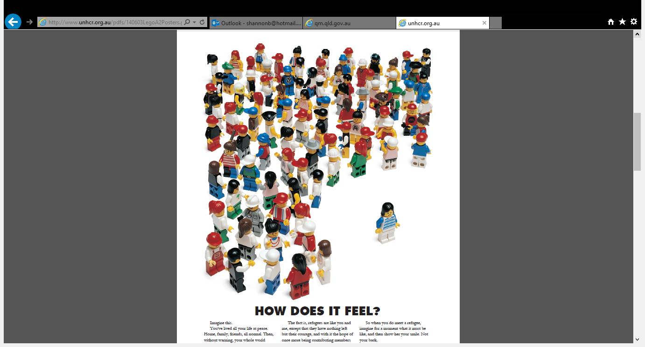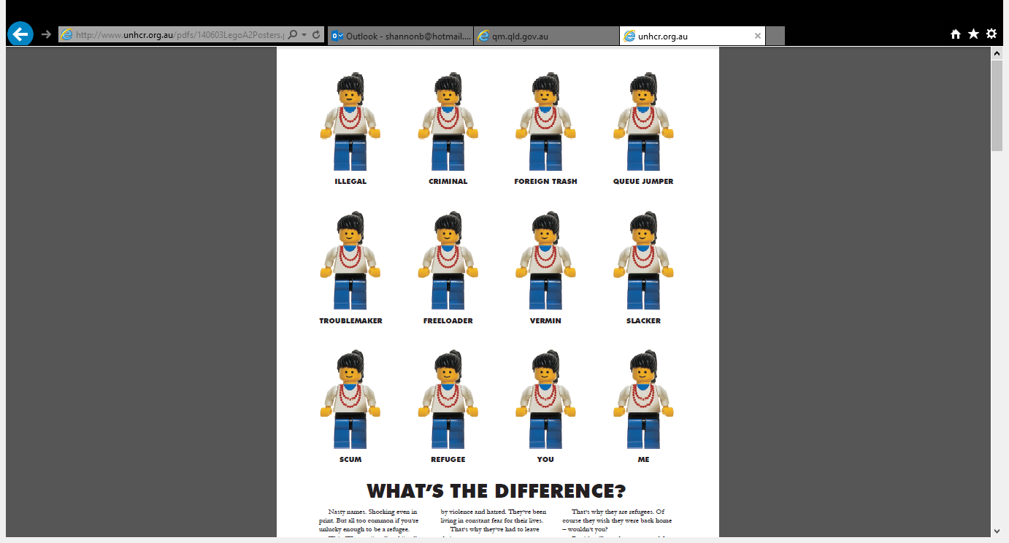

(UNHCR, 2013)

(Refugee Council of Australia, 2013)

## iPad teaching resources related to human rights and social justice

There are many iPAD apps that are available at the App Store. If you search for ‘Human Rights’ there are many that will come up.

**Human Rights – FREE** Students and educators can log on to work through a series of information and activities. Assignments, videos, detailed information and the Human Rights articles are listed for students to work through. For a free app, this would be a fantastic interactive app to use in the classroom, or for students to use at home for homework activities and further reading.

**UDHR Universal Declaration of Human Rights** – **FREE** educates about the rights of every human being in the society, for all languages.

**Human Rights Watch for iPad – FREE** This app brings you the weeks foremost human rights news from around the world as well as Human Rights Watch’s in-depth reports, allowing you to learn more about current challenges and opportunities to create change.

**United for Human Rights Online – FREE** This app is for teachers and students to use as a resource to help bring the concepts of Human Rights to life and make them a reality in the hearts, minds and actions of those who study the subject. These are just a few of the free app’s available. There are many that you can easily download to your iPad or iphone and students will benefit from working with these interactive applications.

## Role play Scenario

## 

(Queensland Museum, 2013, p.26-29)

**NAME:_________________.**

# SEE THINK WONDER.

Complete this sheet in regards to the picture/s shown:

SEE-What do you see in the picture?

THINK-What do you think is happening?

WONDER-What are the positive and negative aspects of the picture?

|  |  |  |  |
| --- | --- | --- | --- |
|  | See | Think | Wonder |
| 1 |  |  |  |
| 2 |  |  |  |
| 3 |  |  |  |

## ttp://www.huma http://www.humanrights.gov.au/education/human-rights-school-classroomnrights.gov.au/education/rights-school-cReferences:

## Australian Government Department of Education, Employment and Workplace Relations. (2013). *Early years learning framework.* Retrieved from http://deewr.gov.au/early-years-learning-framework

## Australian Human Rights Commission. (2013). *Asylum seekers and refugees.* Retrieved from http://www.humanrights.gov.au/publications/asylum-seekers-and-refugees

## Commonwealth of Australia. (2012). *Global education teacher resources to encourage a global perspective across the curriculum.* Retrieved from <http://www.globaleducation.edu.au/teaching-activity/refugees-up.html#activity3>

Edoqs. (2013). *Unit of work on Boy Overboard by Morris Gleitzman.* Retrieved from [http://edoqs.com/pdf/unit- of-work-on-boy-overbooard-by-morris-gleitzman_88437bd359d2f6c179c1f897f8b79aaf](http://edoqs.com/pdf/unit-%09of-work-on-boy-overbooard-by-morris-gleitzman_88437bd359d2f6c179c1f897f8b79aaf)

## Global Words. (2012). *Refugees and migration: Upper Primary English, Year 6.* Retrieved from http://www.globalwords.edu.au/units/Refugees_UPY6_html/documents/Push_pull_factors_survey.pdf

## Hancock, J., & Leaver, C. (2006). *Teaching strategies for literacy.* South Australia: Australian Literacy Educators’ Association.

## Krause, K., Bochner, S., Duchesne, S., & McMaugh. (2010). *Educational psychology for learning and teaching.* South Melbourne: Cengage Learning Australia.

Queensland Museum. (2013). *A journey of understanding refugee cultural studies.* Retrieved from http://www.qm.qld.gov.au/microsites/jou/pdf/Refugee%20Curriculum%20Plans%20and%20Activities.pdf

## Refugee Council of Australia. (2013). *Teacher resources.* Retrieved from http://www.refugeeweek.org.au/resources/2012_RW_ResourceKit_Ch5.pdf

Robinson, B. (2013). *8 reasons to teach children about human rights.* Retrieved from <http://www.unicef.org.au/Discover/unicef-australia-blog/Feb-2013/8-Reasons-to-Teach-Children-about-Child-Rights.aspx>

School Curriculum and Standards Authority. (2012). *Boy Overboard by Morris Gleitzman*. Retrieved from [www.acwa.wa.edu.au](http://www.acwa.wa.edu.au)

Swan, C. (2009). *Teaching strategies for literacy in the early years.* South Australia: Australian Literacy Educator’s Association Ltd.

UNHCR. (2013). *The UN refugee agency.* Retrieved from http://www.unhcr.org.au/pdfs/140603LegoA2Posters.pdf

United Nations. (2004). *Teaching human rights practical activities for primary and secondary schools.* Geneva, Switzerland: United Nations Publications.

Victorian Curriculum and Assessment Authority. (2013). *AusVELS.* Retrieved from http://ausvels.vcaa.vic.edu.au/

Winch, G., Johnston, R., March, P., Ljungdahl, L., & Holliday, M. (2010). *Literacy reading writing and children’s literature* (4th ed.). New York: Oxford University Press.