Name: Shannon Baron ID: 30092723 Professional Experience Learning Tasks
University Professional Experience Mentor: Maree Moore Date submitted: 23/08/14
Professional Knowledge | 1. Know students and how they learn. | 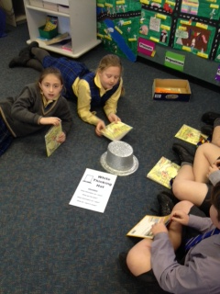  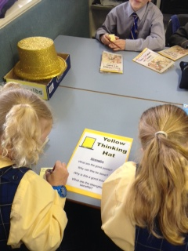  As a part of an English reading group activity I incorporated the use of De Bono’s thinking hats. Each group was given a particular hat to use as a focus for their text. Using the thinking hats allowed students to create a greater level of understanding of the text and delve deeper into a discussion behind the meaning of the text.
Learning Task selected
1C: Use higher order thinking strategies to assist your lesson planning i.e Blooms, Gardener, Thinkers Keys, De Bono.
 | 2. Know the content and how to teach it. | 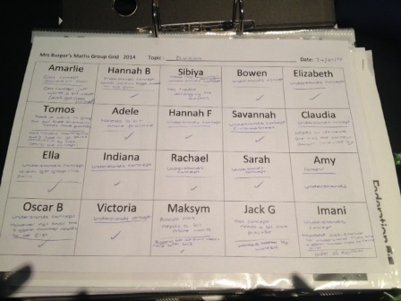  As a form of formative assessment I have been taking anecdotal records on each student in order to assess and monitor student understanding. While I have been using these anecdotal records over a range of subjects I found that it is especially helpful when teaching mathematics. This has allowed me to take notes on individual students, documenting particular aspects that they understand or are having trouble with. These records have also assisted me when planning for future lessons as I am able to identify particular areas in which students are experiencing difficulty.
Learning Task selected
2B: Experiment with an anecdotal record as a way of monitoring student understanding.
 | 3. Plan for and implement effective teaching and learning. | Five Strategies that I can use to get to know the interests and backgrounds of my students include:  - Name Bingo-In this activity each student (and myself) would get a sheet that has different bits of information in different boxes on the sheet. For an example these boxes could have things such as ‘Can play a musical instrument’, ‘Was born overseas’, ‘Is the oldest in the family’, ‘Can speak another language’. The students and I would have to go and find somebody in the class who fits each box. The first person to fill each box with a different name is the winner.  - Top 10 things to know about me page-Students are to create a page which outlines the top 10 things that they believe sums them up. For an example their age, hobbies and interests.  - Question Ball-On a soft ball write a range of different getting to know you questions. Students are to pass the ball around between them. Students are to answer the questions that their hands are placed on when they catch the ball.  - Introduction Video-Students are to create their own introduction video which sums them up in approximately 2 minutes. Not only does this involve the use of ICT but it also means that these can be taken home and watched to assist you in getting to know the students in your class.  - Toilet paper tell me-Students are to take some squares of toilet paper (they can take as many or as few as they like) without knowing the purpose of why they are doing this. The number of squares that they take is the amount of facts that they have to share with myself and the rest of the class.
Learning Task selected
3D: Write down 5 strategies for finding out about the interests and backgrounds of each student in the class.
Professional Practice | 4. Create and maintain supportive and safe learning environments. | 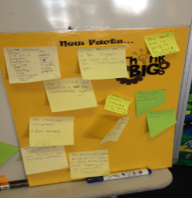  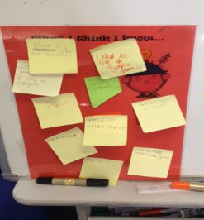  At the beginning of a unit on the Commonwealth Games I got students to write what they already knew/thought they knew about the Commonwealth games on a sticky note. These were then placed on a board under the title ‘What I Think I Know…’ Students then had to write on another sticky note about what they wanted to learn about the Commonwealth Games. These sticky notes were placed under a question mark. This is called a RAN chart. As they learnt more about the Commonwealth Games students could write new facts and put them on another board under the title of ‘New Facts’.
Learning Task selected
4D: Use a pre-teaching strategy i.e a probe, Brainstorming or KWL session to discover what students already know.
 | 5. Assess, provide feedback and report on student learning. | Throughout this placement I have worked with both my mentor teacher and other teachers in the school. I have planned lessons along with the 3/4 team, attended staff meetings and was fortunate enough to participate in a PD day with all staff at the school. During staff meetings and the PD day I was able to participate in discussions regarding the future of the school, different teaching approaches and strategies that the school was implementing and the student learning that had occurred at different year levels. I have also sought advice from not only my mentor teacher but also from other teachers in the school. I have been able to gain different behaviour management strategies that various teachers use, advice in regards to applying for jobs and even advice from a teacher who had taught over in London (which is what I am going to be doing next year). I was also fortunate enough to have a meeting with the Principal and discuss a range of different things such as job applications and interviews.
Learning Task selected
5B: Work co-operatively and purposefully with colleagues and other professionals who share responsibility for the learning and welfare of students.
 | 6. Engage in professional learning. | 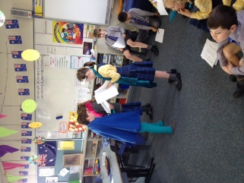  Over two English lessons students took part in in role play activities in the form of ‘Readers Theatre’. Students were separated into three groups. One group used the story ‘True story of the three little pigs’, another group used ‘Sleeping Ugly’ and the last group used ‘The Baker’s Dozen’. This task gave students the opportunity to practice their reading skills while also developing their speaking and listening skills. It was also a great activity for students to participate in group work in which they could use teamwork to complete a task. Students really enjoyed taking part in ‘Readers Theatre’ and were quite enthusiastic about having the opportunity to act a story out, rather than just reading it.
Learning Task selected
6E: Use role-play as a learning activity.
Professional Engagement | 7. Engage professionally with colleagues, parents/carers and the community. | After teaching lessons I have been quite reflective upon my strengths and weaknesses and areas that I need to work on for future improvement. Anna my mentor teacher said to me that one of my strengths is that during/after teaching a lesson I am very good at identifying things that if done again should be done differently. She stated that she doesn’t even need to inform me of these, as I have already identified them myself before she has the opportunity to discuss it with me. Throughout my placement I have been working with Anna to set personal goals in which I can aim to achieve while on placement. These goals are based around areas that I would like to strengthen and develop. Examples of these include being more assertive when giving students directions and using a variety of behaviour management strategies rather than the same ones all of the time.
Learning Task selected
7B: Be aware of your own strengths, preferences and needs as a learner. Identify areas for development as an emerging practitioner and member of the profession.

