Shannon Baron

Bachelor of Education 1st Year Placement

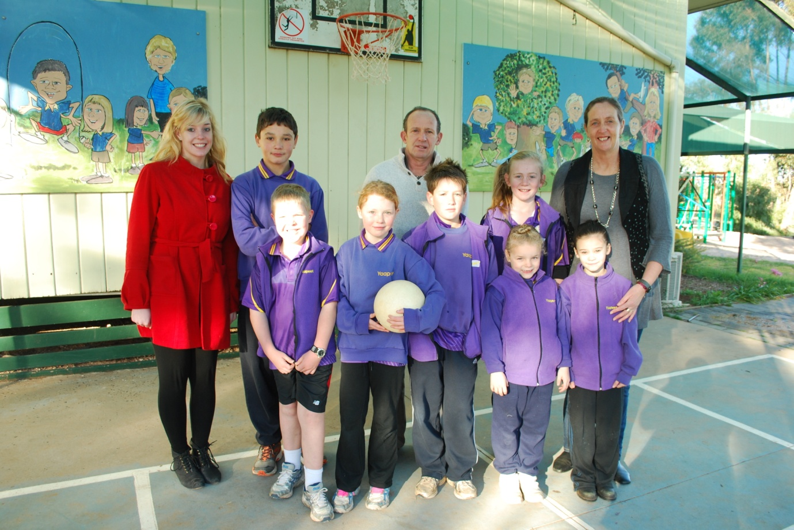

Yaapeet Primary School

18th-29th July 2011

Contents Page:
- Professional Experience Rubric Tasks
- Teachers know how students learn and how to teach them effectively.-1D
- Teachers know the content they teach.-2D
- Teachers know their students.-3A
- Teachers plan and assess for effective learning.-4D
- Teachers create and maintain safe and challenging learning environments.-5C
- Teachers use a range of teaching practices and resources to engage students in effective learning.-6D
- Teachers reflect on, evaluate and improve their professional knowledge and practice.-7C
- Teachers are active members of their profession.-8E

- Lesson Plan (one full lesson)
Research and postcard lesson on Tasmania

- Lesson Plan (small group activity 1)
Read aloud and prediction activity

- Lesson Plan (small group activity 2)
Web Quest on Australian history

- Lesson Plan (small group activity 3)
Estimate and measure activity

- Resource sheets that I have gathered

- Individual Journal/Notes book

1D. Select three classroom management strategies demonstrated by your Mentor Teacher. Describe each one in a descriptive paragraph.
Three strategies that my mentor teacher uses for classroom management include team points systems that lead to rewards, the hands up one person speaking at a time rule and the help/correction table that is written on the board.
Team point system: In this strategy students are placed into groups. Each time a student does some sort of positive behaviour or completes work correctly they are rewarded with a number of points for their group. The greater the achievement or positive behaviour the more points are given. Points are written on the board under the heading of each group and at the end of each term the team with the most points gets some kind of reward. This point system encourages students to do their best in the hope of receiving a reward.
Hands up one person speaking at a time rule: This strategy means that students must raise their hands if they wish to speak during a group discussion and that only one person is speaking at a time. By having this strategy in the classroom it enables respect for one another as students are not speaking over each other or the teacher. It also ensures that everyone’s opinions are heard and that the quieter students are not left out. By ensuring that only one person is talking at a time, noise levels do not get out of hand and there is complete control over the class at all times.
Help/correction table on the board: The help correction table is a table that is drawn up on the board at the start of the lesson. Students who require help from the teacher write their name under the help section of the table and students who require their work to be corrected write their name under the correction section. This makes teachers aware of whom exactly they need to see, so that they can move around the room assisting students in an orderly manner. It helps to stop students from waiting around with their hands up and allows them to continue working, while at the same time removes the pressure that the teacher has of being fired a million different questions at the same time.

2D. Find where your MT obtains their information about the content they teach. List and briefly describe examples.
My MT had been a teacher for over 10 years and therefore obtains a lot of information about the content that they teach from things that they have built and developed over the years. This may include information and ideas from their own university placement, previous lesson plans that they have used that worked well and their own general experience. They also obtain information from the Australian Education Department website (www.education.vic.gov.au/). This website provides them with information about curriculum planning, the VELS and standards that they have to teach to, forms of assessment, different policies and guides and numerous resources for all of the different domains that are taught from prep to 10. My MT also uses textbooks that are structured in conjunction with the VELS in her classroom. These are already planned and ensure that all aspects of each VELS level are addressed.

3A. Observe your MT’s strategies for building relationships with students. Document and reflect on these strategies.
My mentor teacher (MT) knows each of the students extremely well and has a great relationship with all of them. As Yaapeet is such a small school my MT is able to spend time with each individual by themselves and this therefore strengthens their relationship to a greater extent. She builds her relationships with the students by asking them questions about themselves such as what they did on the weekend. By asking her students questions like this she gets a greater insight to their present interests and makes them aware that she is interested in what they are doing. This makes students feel cherished and as if they are important, little things like this can impact on student’s feelings of self-worth. I believe that knowing students interests is vital, as it enables teachers plan lessons which children enjoy. This helps the students to take in more as they are being engaged to a greater extent in what they are doing. Another way that my MT builds relationships with her students is by having a joke around with the students and by sharing information with them about herself, for an example about her interests or sharing stories about her own children. This helps students to acknowledge that she is not just a teacher but also someone that they can relate to.

4D. Use pre-teaching strategy (i.e a probe Brainstorming or KWL session) to discover what students already know.

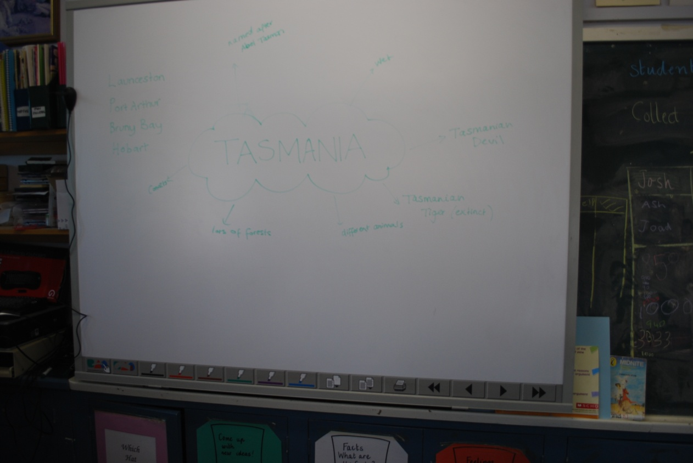
As apart of my whole class lesson on Tasmania I used brainstorming to discover what students already knew. At the start of the lesson I wrote the word Tasmania on the board and asked students to tell me what they already knew about Tasmania, this gave me an insight to what they should be researching and what they may have already covered. At the end of the lesson, as a part of the conclusion I got students to tell me what they had learnt from their research activity. I then added the new information to the board. By using the brainstorming at the beginning and then adding to it at the end of the lesson, it was a good way to assess just how much the students had learnt. Brainstorming proved to be a successful way of finding out what children already know and I am certain that I will use it as a teaching strategy again in the future.

5C. Make notes on the organisation and routines of your classroom. Understand how physical layout aids in the construction of routines for students.
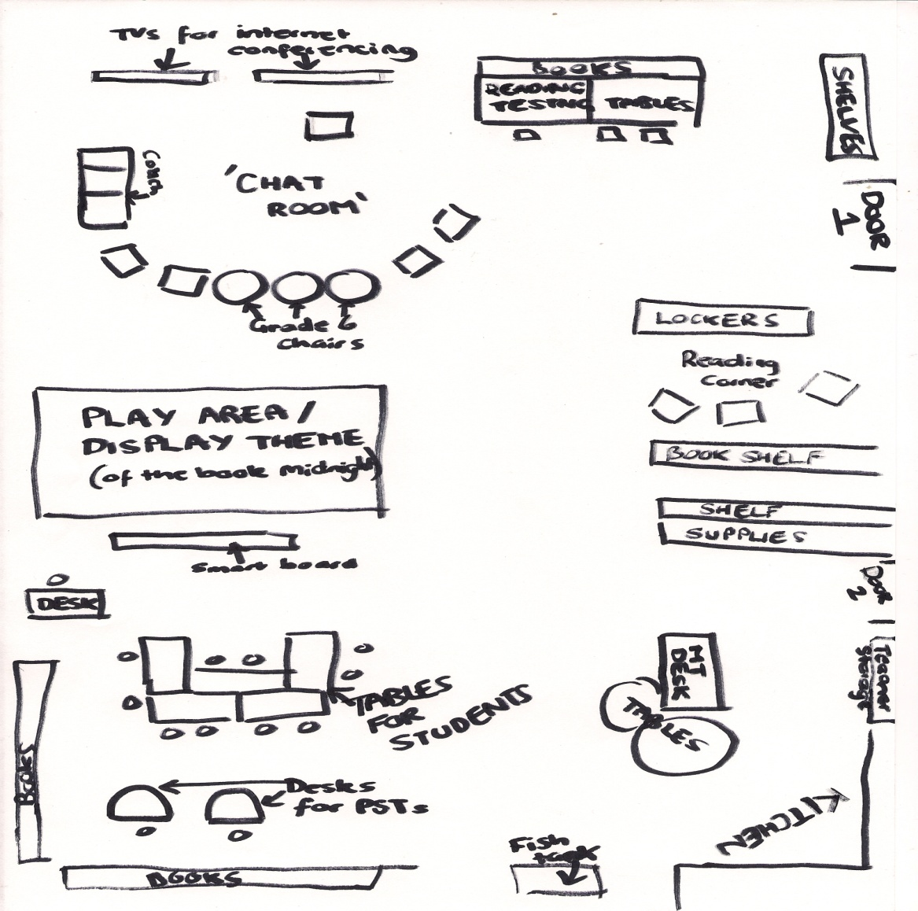
The classroom is organised in a spaced out manner, this assists children in moving around without confrontations. The fact that there are separate sections for reading and reading testing means that other students are not disrupted from their work by hearing the voice of another student reading aloud. The ‘chat area’, where stories are read and informal discussions between the students and teacher take place, and the tables where students complete written work, are separate. This helps children to acknowledge that when they are at the tables they really have to concentrate, talk in moderate levels and get their work done. The only downsides to this layout are that the books for guided reading are a bit crowded and hard to access, and that sometimes when students are spread out for group work it is difficult to see and monitor every student from certain sections of the room. Ideally it is important to have all equipment in assessable places and to be able to monitor all students at all times.
Routines play a big part in each day at this school. Each morning before school the two grade one girls read to the teacher, the bell rings and the student’s line up at the front. The morning generally consists of a huff and puff session, followed by a story and then English activities. After recess maths activities are completed until lunchtime and then after lunch an activity such as art or library may occur, or work on projects that are currently being completed. Also at the beginning of each day the MT has written on the board what the students are doing for the day and the approximate times to when they will be doing each activity. By having a routine and by writing an itinerary on the board it assists children in staying on track and helps them to know what to expect. It also encourages organisation and students using their time wisely.

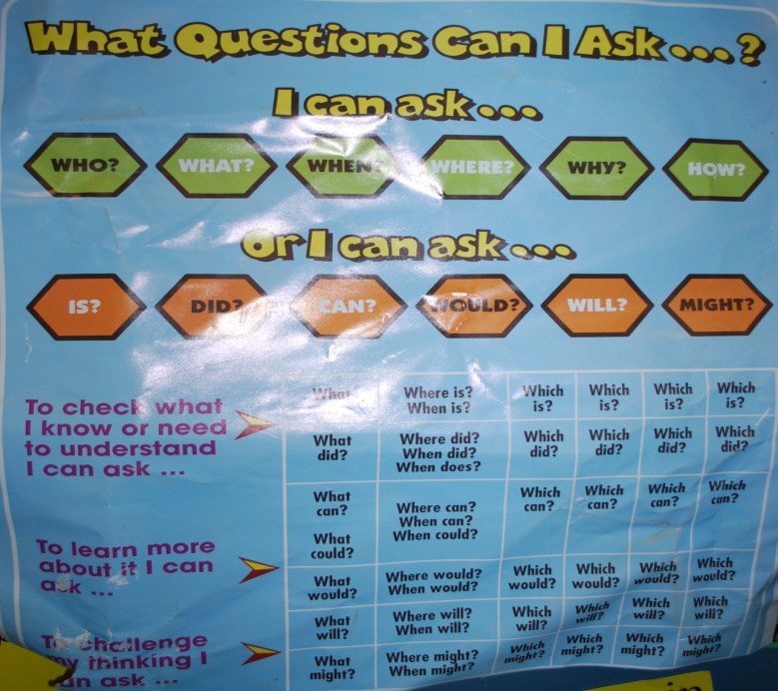
6D. Select 1 literacy and/or 1 numeracy resource that your MT uses to engage the students and support learning. Describe the practice and resource and how it engaged and supported the students. Be specific-what behaviours did you observe.

This is a literacy resource that my mentor teacher (MT) used to help engage and support the students when they were constructing sentences. My mentor teacher used this chart when students were doing journal writing about the best thing that they did over the holidays. The poster was used as the students and the MT discussed the sentences that each child was going to write. Once the student had explained what they had planned to write the teacher got other students to ask them a question like those on the poster, using who, what, when, where, why, how, is, did, can, would, will or might, about something else that they wished to know regarding what the student had shared. By asking these questions students were engaged to a greater extend as the genuinely were interested in what the others did over the holidays. These questions also gave students ideas about what else they could include in their journal entry, and how they could add greater detail to make it more interesting.

7C. Complete a written self-reflection each day and discuss with your professional partner.
DAY 1: Today I picked up on several things that I thought would be great to use when I am a teacher myself. These include the help/correction table on the board, the magic scrap game which makes cleaning the classroom at the end of the day a game and the idea of having a book that students write down words that they are unsure about and get these checked. I also recognised the need for organisation at the end of each semester, to ensure that everything is packed away and finish in order for students to start fresh at the beginning of each semester. Today I saw the poster of questions that students should ask themselves when writing sentences be used and found that it proved to be a very useful resource that helped children gain ideas about what to write and add detail to their sentences. I also recognised that I need to question go over my maths, this was as a student asked me a question and I was not able to help them. I think that by having a subject on maths at uni this semester may be able to help me to improve in this area.
DAY 2: Today my professional pair, MT and I discussed ideas about behind what we could do our small group activities and whole lessons on. This made me feel more comfortable as it means that I now know what I am to do and have plenty of time to plan and prepare. It also helped me to acknowledge that when you are a teacher it is important to plan carefully and be organised. I learnt of the ‘two stars and a wish’ reflection tool that can be used to help children become aware of their strengths and maybe where improvement could be made, and the importance of discussion and reflection with the students at the end of each lesson. Today I was able to successfully able to help a student in maths with their fraction problems. This helped me to gain some confidence back as after day one I felt as if I would never be able to teach maths, however after being successful I now feel that I am able but that it may just be something that I can try and improve on and strengthen.
DAY 3: Today I recognised the importance to not over assist children as if you provide them with too much assistance they begin to rely on you for things that they would be quite capable of doing by themselves. I saw how beneficial it can be for children to work together and found that they can often bounce ideas off each other and provide assistance. I liked the idea of overseas pen pals through email that Yaapeet PS has with a school from England. It not only helps them to build friendships with others across the world but it also helps them to learn about other cultures and improve their literacy skills. When we went on an excursion to the Rainbow PS this afternoon for grade 6 orientation, I noticed an idea of a job roster chart that I thought was a very creative and practical way of setting out who does what job each week.
DAY 4: Today I took notice of the management strategy of one person speaking at a time, and that children must be aware that each child is good at something even if it is not the same thing that everyone else is good at. Both of these things help students to develop respect for another which is vital for cooperative classroom. I learnt the importance of lesson planning (especially in the first few years of teaching) and of having follow up activities for students who finish their work quickly. I also become aware of just how much you can use video conferencing for and how it can help to improve student’s public speaking skills and confidence.
DAY 5: I really enjoyed today especially teaching the small group activities (both the Web Quest and Read Aloud) and the spelling test which I led. This was as they gave me a real insight into what it will be like being a teacher myself. It made me aware of just how much I want to be a teacher and confirmed that I have chosen the right vocation. Today I realised that Yaapeet PS as a small school has other rules and regulations than larger schools. An example of this is that children are not discouraged from doing things such as climbing trees which is highly discouraged at larger schools. At Yaapeet PS the children actually played a game that involved climbing trees during a huff and puff session. As Yaapeet has only 7 students, students are able to more freely do as they wish without as many rules and regulations in place. I also really liked the idea of a Friday afternoon ‘finish off’ in which after lunch children complete any unfinished work from the week. I think this is a great idea that I will adopt as a teacher as it allows children to start fresh each week and to not fall behind.
DAY 7: Today I was able to take some notes on the kind of teacher that I do not want to be. This is as the water-watch/ science teacher who travels around the district came to the school. As I happened to have her as a teacher when I was at primary school and did not enjoy her lessons, it was good to reflect on her again from a different perspective and compare as a PST. I found that she was highly unorganised and often seemed to get stressed which in turn put pressure onto the students. I recognised the need to check that websites that are to be used work on the school computers (as often they can be blocked) before a lesson and that student’s loose focus after completing the same activity over a long period of time. This made me realise that the length of lessons should be taken into consideration when planning a lesson.
DAY 7: I really enjoying taking the small group activity on estimation and measurement today as again it gave me a real insight to what it will be like to be a qualified teacher. The lesson seemed to be quite successful and I think that I would use it again. I realised the advantages of using a correction tub for students to place their completed work and that it is a great way of keep things organised. I also observed how helpful counters or counting frames are when doing addition with younger students. I also really liked the game played at the end of the day ‘last one to’ which is a modified version of ‘Simon says’ and I think this would be quite a good game to play when I have my own classroom.
DAY 8: I recognised today that putting individuals together in groups for any type of points or rewards system is a good idea. This is as it not only encourages team work but also decreases the likelihood of the same students winning all the time, which eliminates the risk of some students getting teased for being a ‘goody goody’ or a ‘teachers pet’. I acknowledged that when students write they only often put the main points and lack important words which helps their writing to make sense, and that it is important to remind students to add this in to ensure that what they are writing is understandable and flows. I also realised just how important it is to think carefully about who works well together when getting children to work in pairs or groups as it can greatly impact on how much they learn.
DAY 9: Today I did my whole class lesson and was happy with how it went. I really enjoyed myself and can imagine myself taking a class in four years time. I liked the idea that my MT used today of students having their eyes shut when there is a class vote. This is so that students are not influenced by others. I also took ideas from Hopetoun PS when we visited today on an excursion. These were having a 10 second time table board, where students who can complete their times tables in 10 seconds names are displayed, the idea of students having buddies and using a magnetic board for a job roster. I also noted down the web address www.folj.com for some great problem solving activities that can be used to build teamwork.
DAY 10: I noticed today how well it works to put up a list of things that students are to work through in a given time frame. I found that it gave them an aim and helped them to stay on track. I liked the system of correction that is used by my MT. This is to put a dot rather than a cross on the students work when they get something wrong, so that they can then go back and fix it. I also liked how students had to get the page of the textbook signed off when they have completed it. At the end of today I also reflected upon just how much I have got from this placement and that already I am looking forward to the next one.

8E. Participate in aspects of school life (i.e interact with staff in the staffroom and attend school assemblies).
While at Yaapeet Primary School I have participated in numerous aspects of the school life (this is especially easy as Yaapeet is such a small school). I have interacted with the staff at the school both before and after school and during lunchtimes and recess and have gotten to know each of the students and have joined in with their games at lunchtimes. I have attended school assemblies, the grade 6 orientation day at Rainbow SC, an illustration session at Hopetoun Primary school and have even helped with the new vegetable garden. I think that participating in the school community has helped me to connect with both the students and staff at Yaapeet Primary and has even gave me an insight to what Yaapeet is like as a community.

