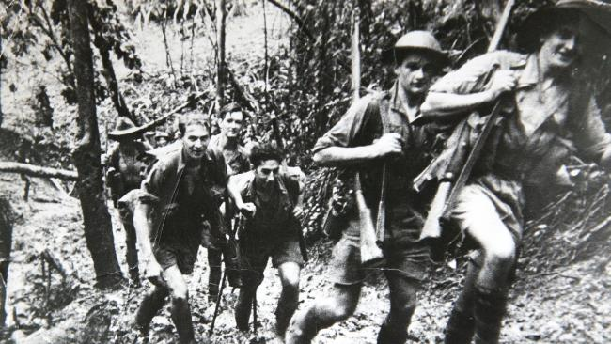
WEB QUEST-Kokoda
Name:_____________________________.

Visit the website:
http://www.ww2australia.gov.au/asfaras/kokoda.html and conduct research on Kokoda in order to answer the following questions. You will need to go to sub headings/links from the main page in order to answer all of the questions. Ensure that you answer these questions in full sentences.

- Why did the battle of Kokoda take place?

- Why were the native villagers who lived along the Kokoda track referred to as the ‘Fuzzy Wuzzy Angels’?

- List and explain two things that you learnt from researching this webpage? (These must be different from the answers above.

